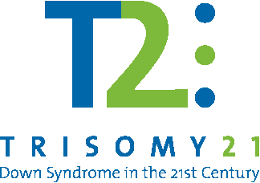

2012 CONFERENCE SCHEDULE

8:00 am – 8:30 am | Presenter Booths Open | Registration / Continental Breakfast
8:30 am – 8:45 am |  | Welcome / Opening Remarks
8:45 am – 9:15 am |  | Keynote Speaker: Emmanuel Bishop  “Before and After”
Tri-Strand Topics |  | Educational Strand | Medical Strand |  | Parental Strand
9:35 am - 10:50 am |  | Reading  Lillian McEnery, PhD, University of Houston Clear Lake | Sexual Development in Children and Teens with Down Syndrome  Adiaha Spinks-Franklin, MD, MPH, FAAP, Developmental Pediatrics, TCH |  | Using Technology to Meet IEP Goals  Betsy Furler, SLP  Bonita Merrill, SNApps Volunteer Coordinator
11:10 am – 12:25 pm |  | A Framework for Simplifying Small-Group Differentiated Learning  Glenna Tabor, Glenna Tabor Consulting | Nutrition  Caroyl Gilbert, RN, MSN, CPNP-PC, Gastroenterology, Hepatology, and Nutrition Service, TCH  Laura Hinkson, RD, Gastroenterology, Hepatology, and Nutrition Service, TCH |  | Evaluations  Matt Cohen, Matt Cohen & Associates
12:25 pm – 12:45 pm |  | Pick Up Lunch
12:45 pm – 2:15 pm |  | Keynote Address: Matt Cohen,  Matt Cohen & Associates  Effective IEPs: Strategies and Long-term Goals
2:45 pm – 4:00 pm |  | Keeping Transition Planning and Services from Falling Through the Cracks: Key Challenges for Schools and Parents- A Total Shift in the IEP Process and in District Responsibilities  Matt Cohen, Matt Cohen & Associates |  | ”Acquiring the Language”: Medical & Evidence-Based Approaches For Speech-Language Disorders In Children With Down Syndrome  Kathryn K. Ostermaier, MD, FAAP, Clinic Director, Texas Children’s Down Syndrome Clinic  April Brackett, MS, CCC-SLP, Speech, Language and Learning, TCH  Kasey Vernon, MS, CCC-SLP, Speech, Language and Learning, TCH |  | Behavior  John Pugh, BCBA, Behavior TLC
4:15 pm – 5:15 pm |  | Question & Answer Session  Matt Cohen, Lillian McEnery, Glenna Tabor, Adiaha Spinks-Franklin

