Galveston-Houston Families Exploring Down Syndrome

Step Up for Down Syndrome Walk 2015

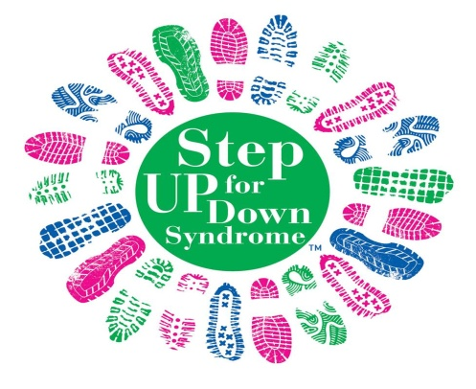

The 2015 Step Up For Down Syndrome Walk will take place at Walter Hall Park, 807 Hwy 3 in League City on Saturday, October 3rd, 2015 from 9am-noon.

The Step Up Walk provides the entire community the opportunity to celebrate individuals with Down syndrome and their families. The event promotes the acceptance of all people with Down syndrome. There are over 280 Down syndrome walks held worldwide!

Individual registration is $15 for individuals 13+ and children 12 & under is $5, Team Captains and Individuals with Down syndrome are FREE. You may register online by visiting https://secure.ezeventsolutions.com/fr/GHFEDS/2015Walk

Each team captain will receive a free walk sign honoring their loved one and team. You may register for a walk sign online at www.ghfeds.org and attach your favorite head shot photo of your child. Buttons will be available to purchase online and deadline for buttons and walk sign is September 14th.

Online registration makes it easy!

What does the website provide?

- It’s easy and fun!
Allows participants to register online as individual walkers or as
members of a team.

- Build your own web page!
Participants have access to a personal page which can be customized
by editing text, adding pictures and modifying layout and colors. Tell
your personal story!

- Send emails!
Participants can send e-mails through the online tools section and solicit pledges (optional). People you solicit will be able to donate online to your team total.

- Check your team’s progress.
Participants can view the total funds raised for the team and send
thank you emails.

- Online video tutorials.
Online video tutorials help you navigate the website and set your
team up for success!

Walk FAQS

Does the registration fee apply to kids?
Yes, this helps us cover the costs of t-shirts, entertainment, food, etc.

Are my team members required to register online or can I do it for them?
You can build your team by having participants register using the Walker Registration Form. However, team captains are responsible for entering all walkers and sponsors from the form into the online system. Walkers and sponsors must be in the online system to count toward your team totals and to ensure that your walkers receive their t-shirts.

Do my team members need to stop at the registration table the day of the walk?
Yes, team captains can alleviate a lot of waiting in line for their team members by picking up
shirts. We recommend you pick a designated meeting spot at the park for your team so you can pass out shirts.

When should I tell my team to get to the park?
We advise you to tell your team to arrive at Walter Hall Park no later than 9:30 a.m. We’ll start walking at 10:00 am. You will want to get your team organized and together before the Walk begins.

Does the Walk happen rain or shine?
While we never hope to have it rain on our parade, we host the Walk regardless of the weather!

What should we bring with us to the Walk?
Bring any donations you have yet to turn in, your Walk t-shirt(s) and a great attitude!

How are funds raised at the Walk used?
Proceeds fund a variety of programs and services to benefit people with Down syndrome and their families. To learn more about GHFEDS please visit www.ghfeds.org

The perfect way to honor your loved one with Down syndrome - Create a Walk Team

A Walk team can consist of your immediate family or 200 of your closest friends, family and neighbors.

Most teams choose a name which honors their loved one with Down syndrome to build team spirit. Each person on your team is required to pay the applicable registration fees to walk and sign the waiver of liability form.

How do I form a Team?

If you are not sure who to ask to be on your team, just look around you. Invite your neighbors, family, friends, business associates, teachers, coworkers, doctor, dentist, church family, mechanic or other people you interact with on a regular basis. You will probably be pleasantly surprised by the show of support you receive!

Contact potential teammates in person or by phone if possible. Email and letters are good alternatives for those people you can’t reach directly. Personalize your approach by asking them to help you support this important cause.

Explain to them why it’s important to you and how you became involved with the Step Up for Down Syndrome Walk. Encourage your teammates to spread the word and invite others to join your team or start a Walk team of their own by registering at walk.gclfeds.org.

When you have your team assembled, hold a team get together. Get everyone involved and give them advice and encouragement. You might also consider providing your team members with a photo of your honored team mate to accompany any pledge envelopes they are using. Remember that everyone on your team will have a greater awareness and appreciation for Down syndrome after attending the Step Up for Down Syndrome Walk with you!

The number one reason people don’t donate is because they are not asked!

How to raise $250 in only ten days!

Day 1: Make a personal $25 contribution. | +$25 = $25
Day 2: Ask your significant other for $15 contribution. | +$15 = $40
Day 3: Ask your mom or dad for $15 contribution. | +$15 = $55
Day 4: Ask a friend for $15 contribution. | +$15 = $70
Day 5: Ask your boss for $25 contribution. | +$25 = $95
Day 6: Ask three co-workers for $15 contribution. | +$45 = $140
Day 7: Ask your sister or brother for a $15 contribution. | +$15 = $155
Day 8: Ask your in-laws for a $15 contribution. | +$15 = $170
Day 9: Ask two neighbors for $15 contribution. | +$30 = $200
Day 10: Ask a business owner for a $50 contribution. | +$50 = $250



